Project Title: Designing the system to be York U Parking System

In deliverable 1, we are submitting the following :

* One report file
* One diagram folder including all PNG diagrams and XML
* in the diagram folder, there are sub folders for each task.
* For each folder we have included the PNG and it is corresponding XML file

Part 1.

**Task 1. Use Case Diagram**

Figure 1. Use case Diagram

**Task 2. Activity Diagram**

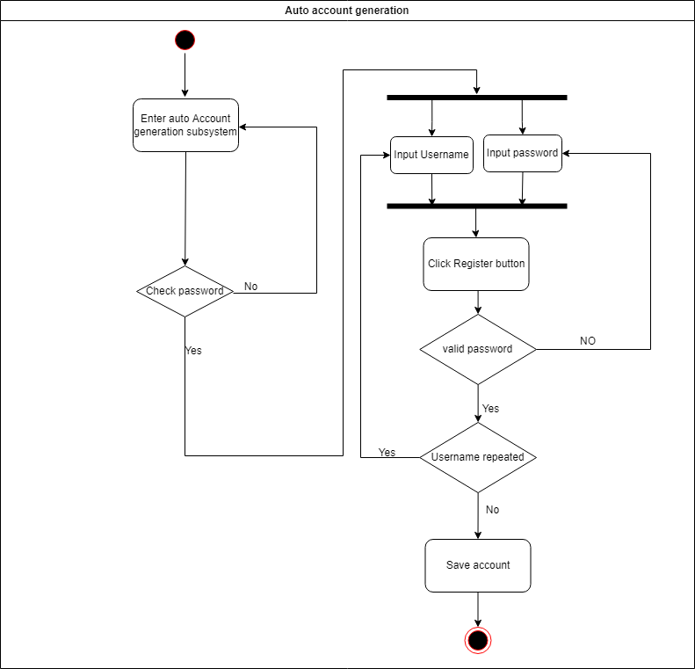

**Fig 2. Auto account generation system**

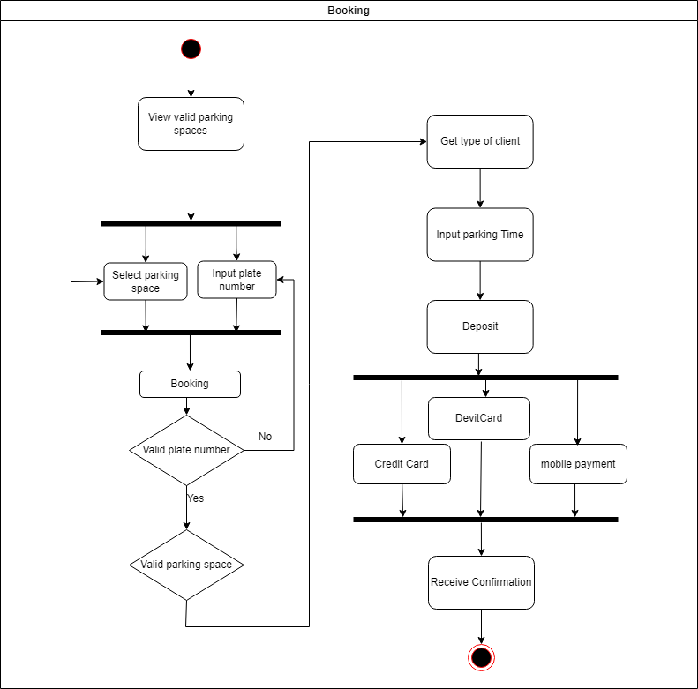

**Fig 3. Booking**

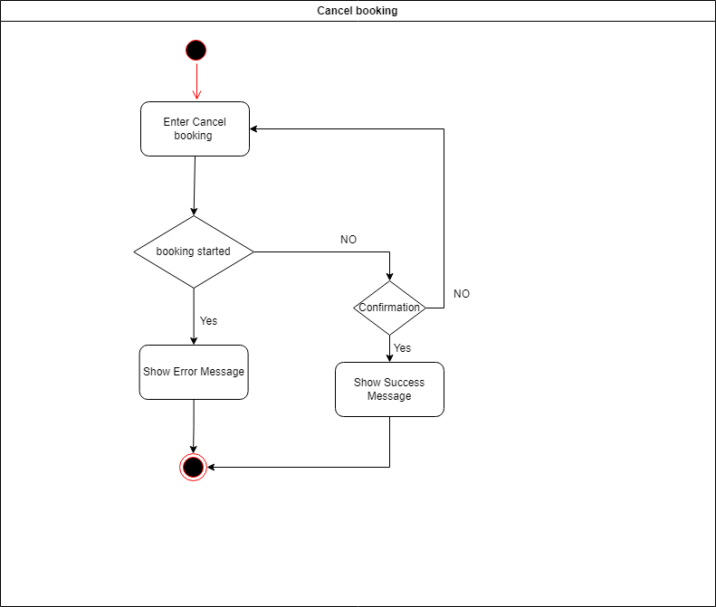

**Fig 4. Cancel Booking**

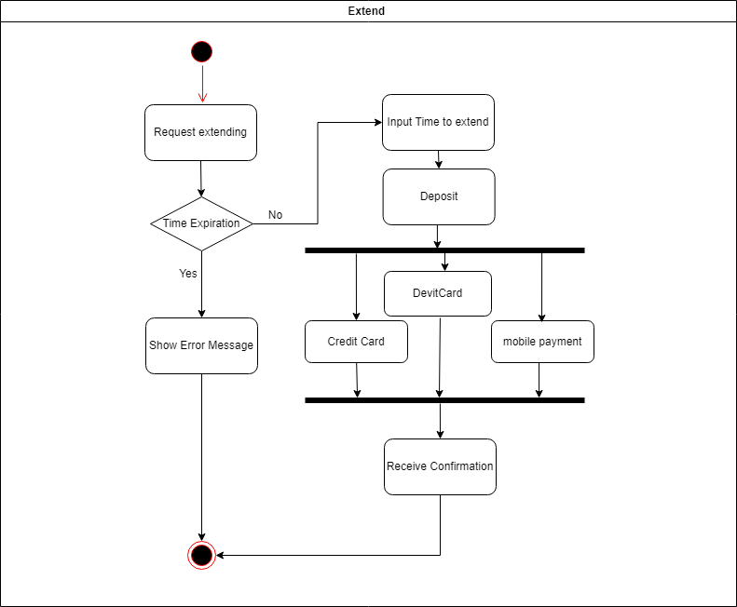

**Fig 5. Extend Booking**

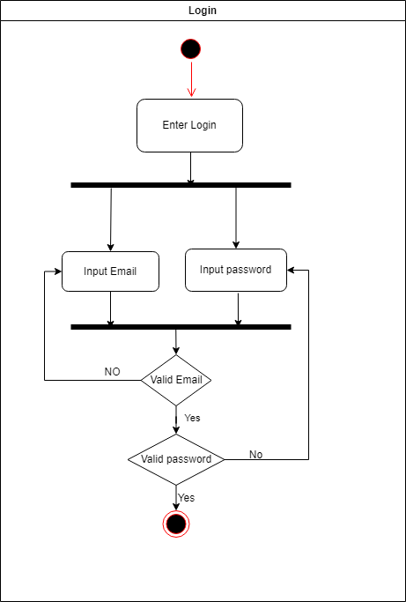

**Fig 6. Login**

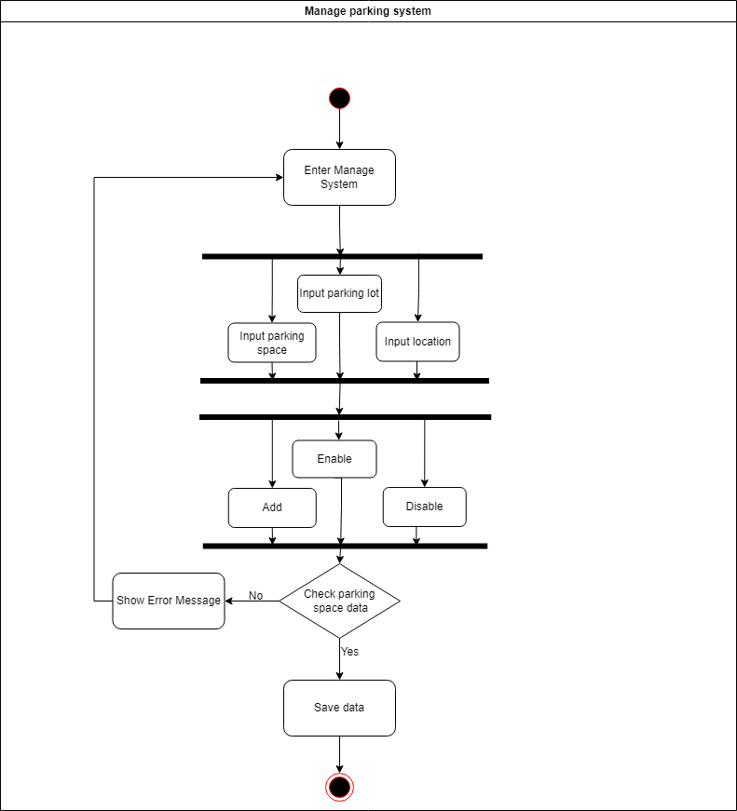

**Fig 7. Manage System**

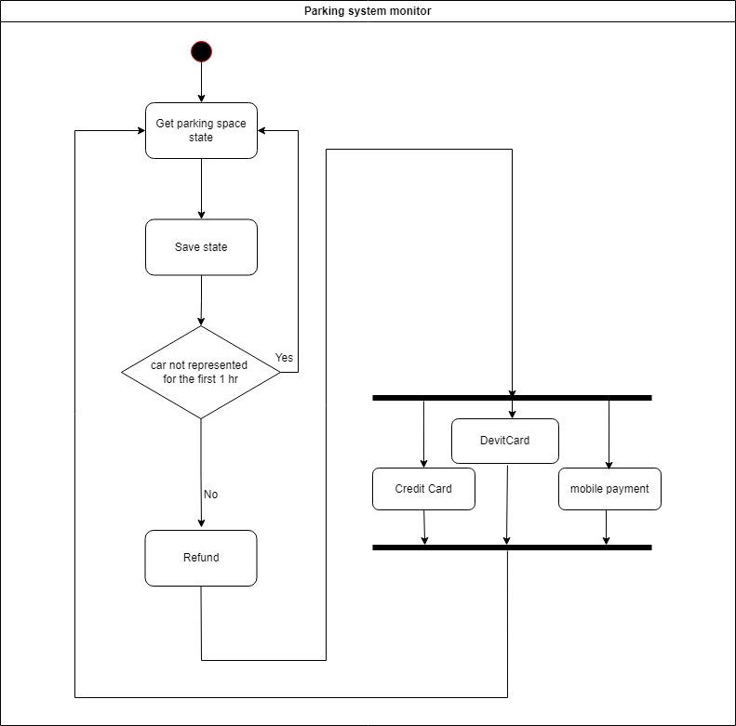

**Fig 8. Parking System Monitor**

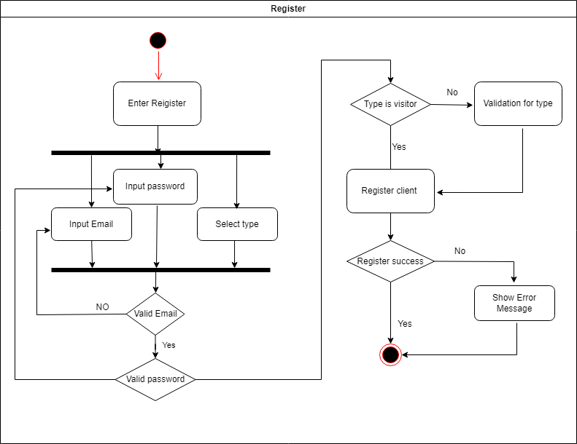

**Fig 9. Register**

**Task3. Sequence Diagram**

**Fig 10. Booking**

**Fig 11. Extend Booking**

**Fig 12. Cancel Booking**

**Fig 13. Cancel Booking**

**Fig 14. Parking System Monitor**

**Fig 15. LOGIN**

**Fig 16. Register**

**Fig 17. Auto account generation system**

**Part 2. Class Diagram**

Fig 18. Class diagram

